CDG Press Release to Catering & Design Trade Press – 6/4/22
Catering Design Group is now Gas Safe registered
Daventry based Catering Design Group has now achieved Gas Safe registration.
As one of the only UK-based interior design houses to achieve this industry recognised certification, this will enable CDG to bring more design and build services in-house, benefiting our clients with a more efficient and cost effective service.
The Gas Safe register is the official gas registration body of gas businesses and engineers in the United Kingdom, Isle of Man, Jersey and Guernsey.
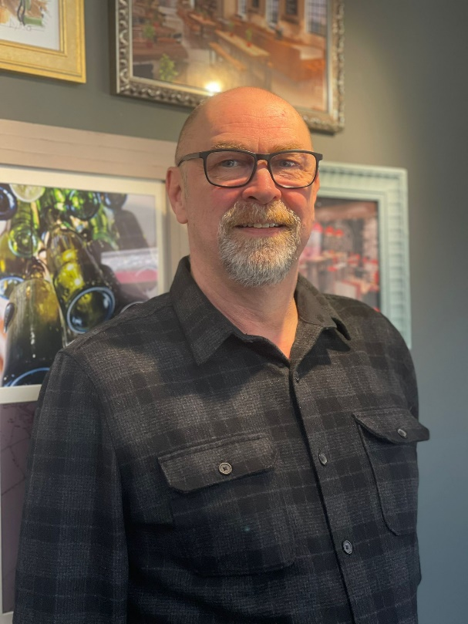
CDG’s gas safety qualified engineer is Jason Crust. Jason joined the team as a Project Manager in 2021 having started his career as an apprentice at Corgi over forty years ago.

Gary Crosbie, Managing Director has said;
‘’We’re at an exciting time of growth at CDG – building a strong and well-qualified team and taking on new and exciting projects. Registration to Gas Safe enables us to extend our offering to clients, providing a full end-to-end design and build service.’’.

Jason Crust – CDG Project Manager

Notes to Editors
- Catering Design Group is one of the UK’s leading restaurant and commercial kitchen design companies, offering a full design service to clients throughout the retail, leisure, hospitality and education sectors. http://www.cateringdesign.co.uk
- For further information please contact Paul Bioa, Business Development Director on +44 (0)7736 479342 or email paul.boia@cateringdesign.co.uk
- For further information regarding the Gas Safe Register, please visit What Is Gas Safe Register? - Gas Safe Register.
- Images – Gas Safe logo and CDG Project Manager Jason Crust.

